# DR. AMBEDKAR INSTITUTE OF TECHNOLOGY

(An Autonomous Institution, Affiliated to Visvesvaraya Technological University, Belagavi) Near Jnana Bharathi Campus, Mallathahalli, Bengaluru-560056

### DEPARTMENT OF CIVIL ENGINEERING

NSS ACTIVITY REPORT ON

SOCIO-ECONOMIC SURVEYS ADOPTED IN VILLAGES

TOPIC: “WATER SUPPLY AND SANITATION SURVEY” SUBJECT CODE: 21HSN803

SUBMITTED BY: AMIT R E 1DA21CV006

3rd Year, 5th Sem ‘A’ section

DEPT. OF CIVIL ENGINEERING

#### UNDER THE GUIDANCE OF

Ms. SUPRITHA R M

ASSISTANT PROFESSOR DEPT. OF CIVIL ENGINEERING

#### Dr. Ambedkar Institute of Technology

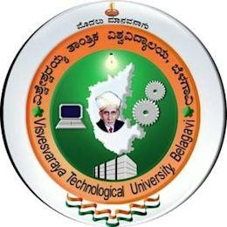

Visvesvaraya Technological University

Jnana Sangama, Belagavi, Karnataka – 590018 2022-2023

# Dr. AMBEDKAR INSTITUTE OF TECHNOLOGY

(An Autonomous Institution, Affiliated to Visvesvaraya Technological University, Belagavi) Near Jnana Bharathi Campus, Mallathahalli, Bengaluru-560056



**CERTIFICATE**

This is to certify that the report on “Water Supply and Sanitation Survey” Is a bonafide work carried out by AMIT R E (1DA21CV006) of

Dr Ambedkar Institute of Technology, Bangalore. It is certified that all activities instructed for NSS Activity have been incorporated in the report. The report has been approved as it satisfies the academic requirements in respect to the work prescribed for the Bachelor of Engineering degree

|  |  |
| --- | --- |
| **Ms. Supritha R M** | **Dr. S Vijaya** |
| Assistant professor | HOD |
| Dept. of Civil Engg | Dept. of Civil Engg |

**ACKNOWLEDGEMENT**

I take this opportunity to express my sincere gratitude and respect to

**Dr. Ambedkar Institute of Technology,** Bengaluru.

We consider ourselves privileged to express gratitude and respect towards all those teaching and non-teaching faculty members who have guided us for successful completion of Extensive Survey Project-2023-24.

I would like to express my special thanks of gratitude to **Dr. S Vijaya,** Professor, Head of the Department, for creating highly disciplined and professional environment in the department and for his untiring guidance & support for our professional grooming and successful completion of NSS Activity.

I extend my sincere gratitude to our Mentor **Prof. Ms. SUPRITHA R M**, who gave us the golden opportunity to do this activity which also helped us in learning lot of things and we came to know about so many new things. I really thankful to him.

We sincerely thank you for giving us this opportunity to work with such a progressive and forward-thinking organization.

We would like to thank our camp officer Mr. Sharath B Assistant professor in the dept. of Civil Engineering and Mr. Sharath B Assistant professor in the dept. of Civil Engineering for giving me an opportunity to work in this project and for his guidance to work and the support throughout the course of my extensive survey project work.

#### Regards

AMIT R E (1DA21CV006)

5th sem ‘A’ sec

Dept. of Civil Engineering

## CHAPTER-1

### Water Supply and Sanitary Project:

* 1. Introduction:

Next to air the other important requirement for human life to exist is water. The use of water by man, plants and animals is universal. As a matter of fact every being will require water for its survival. The water plays an important role in the manufacture of essential commodities, generation of electric power, transportation, recreation, industrial activity etc. Thus the water can be considered as the most important raw material of the civilization because of the fact that without water, man cannot live and industries cannot survive. With our growing population and industrial development the demand of water is also increasing day by day and every country has to take preventive measure to avoid careless pollution and contamination of the available water resources. In order to ensure these services for all time to come it becomes necessary to maintain conserve and use these resources carefully. It is therefore essential to increase available water resources and their quality by taking remedial measures. It has been estimated that two thirds of human body constitutes of water. Therefore in order to ensure sufficient quantity and quality of water it becomes imperative in modern society to protect the useful supply by launching the appropriate water supply scheme.

#### Objectives

Water quantity management:

Water quantity management is important when there is an increase in population or a population explosion. Increase in migration of people to a certain development area due to job opportunities, quality education, religious/cultural activities, natural disasters in the neighbouring areas, due to commercial or industrial interest or due to economic policies which causes increase in demand for water and rapid depletion of the supplies. This increase in demand forces to use alternate sources of water there by leading to ground water exploitation altering the quality of the ground water and polluting the surface water also. In order to ensure the availability of sufficient quantity of good quality of drinking water, it becomes almost imperative in a modern society, to plan and build suitable water supply schemes, which may provide potable water to the various sections of the community in accordance with their demands and requirements. The provision for such a scheme shall ensure a constant and a reliable water supply to that section of the people for which it has been designed. Such a scheme shall not only help in promoting hygiene and public health, also supplying water for fountains, gardens, etc. for beautification of the surroundings, but also shall ensure safety against fire by supplying sufficient quantity of water to extinguish it.

The existence of such a water supply scheme shall further help in attracting industries and thereby helping in industrialisation and modernisation of the society, consequently reducing unemployment and ensuring better living standards. Water quantity management consists of the following:

* + 1. Identification of the water source.
    2. Suitability of water for drinking purpose.
    3. Reliability.
    4. Volume of water available thought the year.
    5. Economics
  1. Water quality management:

Apart from providing sufficient quantity of water to the people, its necessary to ensure that the water provided is potable i.e., it should be free from turbidity & undesirable tastes, colours & odours. Also other characteristics of water like pH, temperature, hardness should be within permissible limits. Therefore to ensure that the water is safe for consumption, we carry out water quality management, in addition to, water quantity management. Water quality management includes: Carrying out physical analysis of water to determine the physical qualities of water like turbidity, temperature etc, & ensuring that they are within the permissible limits. Carrying out chemical analysis of water to determine the chemical qualities of water like pH, chloride content & ensuring they are within the permissible limits. To ensure that **Biological Oxygen Demand (BOD**) is nil. To ensure that the water is free from pathogenic bacteria. In addition to water quantity management & water quality management, the other objectives of this project are: To meet additional water demands like fire demand & to provide water for recreation.

### Estimation of water demand

It is important for an engineer to evaluate the amount of water available and the amount of water demanded by the public.

Some of the factors affecting per capita water demands are:

* Size of the city.
* Climatic conditions.
* Industrial and commercial activities.
* Pressure in the distribution system.
* System of supply.
* Cost of water.
* Quality of water supplies
* Policy of metering and method of charging.

The various types of water demand which a city may have may be broken down into following classes:

#### Domestic demand:

**Domestic water requirements:**

|  |  |  |
| --- | --- | --- |
| Sl. No | Types of demand | Volume in litres |
| 1. | Drinking | 5 |
| 2. | Cooking Bathing | 5 |
| 3. | Bathing | 55 |
| 4. | Cloth washing | 10 |
| 5. | Utensil washing | 10 |
| 6. | Floor washing | 10 |
| 7. | Flushing of toilets | 30 |
| 8. | Total | 135 |

The table above provides the details of standard utilization of water per person per day in India.

#### Design of Water Treatment Unit:

The water treatment plant is constructed for whole Lagumenahalli village.

#### Discharge calculation:

Considering total water demand = 270 LPCD (it includes the domestic demand, institutional and industrial demands, livestock demands, demand for public parks and fire demand).

Therefore, required discharge to meet the requirement of the panchayath is given by Discharge (Q) = population * Per capita demand lit/day

Peak discharge (Q peak) = Q*1.5

### CHAPTER-2

**Sanitary treatment plant:**

#### Introduction:

Sanitation is the means of promoting hygiene through the prevention of human contact with hazards of wastes especially faces, by proper treatment and disposal of the waste, often mixed into waste water. These hazards may be physical, microbiological, biological or chemical agents of disease. Wastes that can cause health problems include human and animal excreta, solid wastes, domestic waste water (sewage or grey water), industrial wastes, and agricultural wastes. Hygienic means of prevention may involve engineering solutions (e.g., sanitary sewers, sewage treatment, surface runoff management, solid waste management, excreta management), simple technologies (e.g., pit latrines, dry toilets, urine diverting dry toilets, septic tanks), or even simply by behaviour changes in personal hygiene practices, such as hand washing with soap. Providing sanitation to people requires a systems approach, rather than only focusing on the toilet or waste water treatment plant itself. The experience of the user, excreta and waste water collection methods, transportation or conveyance of waste, treatment, and reuse or disposal is called the Sanitation chain and all need to be thoroughly considered The main objective of a sanitation system is to protect and promote human health by providing a clean environment and breaking the cycle of disease.

### Objectives of sanitary treatment plant

1. Improving of surrounding environment

Immediate removal of waste water is the most fundamental role of sewage systems. If the waste water generated by the human activities is not removed and remains near residential area, public hygiene will not be well maintained and the living conditions will become worse. By promotion of sewage system waste water is removed immediately, and surroundings environment is greatly improved.

1. Prevention of flooding

Drainage of water in urban areas and prevention of the flooding is one of the important roles of sewage systems. In recent years especially with the advancement of urbanization, rainwater permeable areas have been decreased by increase in roads area, construction of buildings and houses etc. As a result, a storm water runoff amount has increased, resulting in increase in occurring of flooding. Coping with this kind of flooding in urban areas have become one of the urgent issues to be solved.

1. Prevention of water quality in public water bodies: To treat the sewage water properly and to remove all the harmful effluents present in sewage before leaving into natural water bodies.

#### Factors affecting sanitary sewage:

The quantity of sanitary sewage is mainly affected by the following factors:

* + - Population.
    - Type of area served as residential, industrial or commercial.
    - Ground water infiltration.
    - Rate of water supply.

### Sources of sanitary sewage:

The following the main sources of sanitary sewage:

* + - Water supplied to the public for domestic purpose by local authorities.
    - Water supplied to the various industries for various industrial process.
    - Water supplied by the local authorities for various public places such as schools, theatres, hotels and railway stations etc.
    - Unauthorised entrance of rain water in sewer lines.
    - Water drawn from well, lakes, canals etc., by households and industries for their purpose.

#### Design of sewage treatment plant:

This sewage treatment plant is designed for treating the waste water of Lagumenahalli village.

**Design of primary sedimentation tank:**

Discharge = Q m3 /s Detention time=3hrs Capacity = Q* 3 = 56.7 m3 Provide effective depth = 2m

Bed slope = 1 in 10 towards centre

Provide 1m depth for sludge collection and 0.5m as free board Economical diameter = 1.22√Q m

**Discharge of sewage:**

Water required per day = Q m3 /s Assume 80% is converted to sewage Total quantity of sewage = 0.8 * Q m3 /s.

# DR. AMBEDKAR INSTITUTE OF TECHNOLOGY

(An Autonomous Institution, Affiliated to Visvesvaraya Technological University, Belagavi) Near Jnana Bharathi Campus, Mallathahalli, Bengaluru-560056

### DEPARTMENT OF CIVIL ENGINEERING

NSS ACTIVITY REPORT ON

CLEANING PROGRAMS ADOPTED AT VILLAGES

TOPIC: “**Swachh Bharath Abhiyan**” SUBJECT CODE: 21HSN803

SUBMITTED BY: AMIT R E 1DA21CV006

#### 3rd Year, 5th Sem

‘A’ section

DEPT. OF CIVIL ENGINEERING

#### UNDER THE GUIDANCE OF

Ms. SUPRITHA R M

ASSISTANT PROFESSOR DEPT. OF CIVIL ENGINEERING

#### Dr. Ambedkar Institute of Technology



Visvesvaraya Technological University

Jnana Sangama, Belagavi, Karnataka – 590018 2022-2023

# Dr. AMBEDKAR INSTITUTE OF TECHNOLOGY

(An Autonomous Institution, Affiliated to Visvesvaraya Technological University, Belagavi) Near Jnana Bharathi Campus, Mallathahalli, Bengaluru-560056



**CERTIFICATE**

This is to certify that the report on “Cleaning Programs Adopted at Villages” Is a bonafide work carried out AMIT R E (1DA21CV006) of

Dr Ambedkar Institute of Technology, Bangalore. It is certified that all activities instructed for NSS Activity have been incorporated in the report. The report has been approved as it satisfies the academic requirements in respect to the work prescribed for the Bachelor of Engineering degree

|  |  |
| --- | --- |
| **Ms. SUPRITHA R M** | **Dr. S Vijaya** |
| Assistant professor | HOD |
| Dept. of Civil Engg | Dept. of Civil Engg |

**ACKNOWLEDGEMENT**

I take this opportunity to express my sincere gratitude and respect to

**Dr. Ambedkar Institute of Technology,** Bengaluru.

I would like to express my special thanks of gratitude to **Dr. S Vijaya,** Professor, Head of the Department, for creating highly disciplined and professional environment in the department and for his untiring guidance & support for our professional grooming and successful completion of NSS Activity.

I extend my sincere gratitude to our Mentor **Prof. SUPRITHA R M**, who gave us the golden opportunity to do this activity which also helped us in learning lot of things

and we came to know about so many new things. I really thankful to him.

We sincerely thank you for giving us this opportunity to work with such a progressive and

forward-thinking organization.

**Regards** AMIT R E 1DA21CV006

5th sem ‘A’ sec

Dept. of Civil Engineering

### CHAPTER 1 SWACHH BHARATH ABHIYAN:

#### introduction

Swachh Bharat Abhiyan, also known as the Clean India Mission, stands as a visionary and ambitious initiative launched by the Government of India to revolutionize the nation's sanitation and hygiene practices. Commencing on October 2, 2014, under the leadership of Prime Minister Narendra Modi, the campaign aims to combat persistent challenges related to poor sanitation, open defecation, and widespread unhygienic practices prevalent across the diverse landscape of the country. In the historical context of India's sanitation challenges, a substantial portion of the population had long endured inadequate access to proper sanitation facilities, contributing to the prevalence of open defecation, diseases, and environmental degradation. Recognizing the imperative for transformative action, the government initiated the Swachh Bharat Abhiyan to usher in a cleaner and healthier era for India.

The primary objectives of Swachh Bharat Abhiyan encompass the elimination of open defecation, enhancement of waste management systems, and the promotion of overall cleanliness and hygiene. The campaign, spanning both rural and urban areas, acknowledges the unique sanitation challenges faced by diverse segments of the population. A pivotal component of Swachh Bharat Abhiyan involves the construction of toilets to eradicate open defecation. The government undertook large-scale efforts to build individual household toilets, community toilets, and public facilities in both urban and rural areas.

Financial incentives were provided to incentivize households, ensuring widespread participation in the initiative. Recognizing that infrastructure alone is insufficient, the campaign places significant emphasis on behavioural change. Extensive awareness programs were launched to educate communities about the importance of sanitation, hygiene practices, and the adverse effects of open defecation.

These initiatives aimed to install a sense of responsibility and promote a cultural shift towards cleanliness. Addressing solid waste management challenges is another crucial facet of Swachh Bharat Abhiyan. Efforts were made to promote the segregation of waste at its source and establish effective waste disposal systems.

The campaign encourages the proper disposal of plastic waste, underscoring its commitment to environmental sustainability. Swachh Bharat Abhiyan acknowledges the diverse needs of both rural and urban areas. In rural regions, the focus is on creating sanitation infrastructure

and promoting behavioral change, while in urban areas, initiatives include waste management, public toilet construction, and cleanliness drives.

The campaign thrives on collaboration, involving partnerships between the government, non- governmental organizations (NGOs), private sector entities, and citizens.

Public and private partnerships play a pivotal role in implementing various components of the campaign, ensuring a comprehensive and sustainable approach. Since its inception, Swachh Bharat Abhiyan has achieved significant milestones in improving sanitation and cleanliness across the country. The construction of millions of toilets has led to a substantial reduction in open defecation. The campaign's emphasis on behavioural change has contributed to a growing awareness of the importance of hygiene practices, leading to positive impacts on public health outcomes by reducing the spread of waterborne diseases.

Despite its successes, Swachh Bharat Abhiyan has encountered challenges and criticisms. Some argue that the focus on infrastructure development may not be sufficient without addressing the root causes of sanitation challenges, such as poverty and lack of education. Instances of toilets being built without adequate water supply or proper maintenance have been reported, leading to underutilization.

#### Process we performed

First, we took the permission from the collage and then we went to the village of Lagumanahalli Where in that village there was gram panchayath office. We went as a group for seeking the permission to encourage the village students to keep the premises clean and we all involved in that cleaning process as a name of Swachh Bharat.

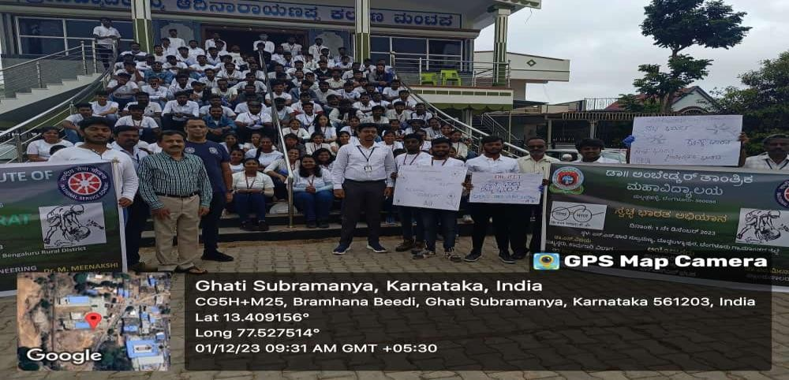

This is team went for the activity with quotes written in the paper. Showing that around your environment should clean and hygiene.

### CHAPTER-2

**Outcomes and Learnings:**

The "Objectives of Societal Transformation" section delineates the specific aims and desired outcomes of the Swachh Bharat Abhiyan, elucidating the roadmap for the successful implementation of this societal initiative. These objectives play a crucial role in guiding the activities and interventions that are instrumental in achieving the overarching goals of the cleanliness and sanitation campaign.

1. **Enhance Sanitation Literacy:** A fundamental objective of the Swachh Bharat Abhiyan is to enhance sanitation literacy within the community. This involves conducting awareness campaigns, workshops, and outreach programs to educate individuals about the importance of cleanliness, proper waste disposal, and the potential benefits of maintaining a hygienic environment.
2. **Facilitate Behavioural Change:** Another key objective is to facilitate behavioural change among the populace, encouraging the adoption of hygienic practices. This includes promoting the habit of using toilets, discouraging open defecation, and instilling a sense of responsibility towards maintaining a clean and sanitary living environment.
3. **Improve Sanitary Infrastructure:** The initiative may aim to improve sanitary infrastructure within communities. This could involve the construction of toilets, the establishment of waste management systems, and ensuring access to clean water, creating an environment conducive to effective sanitation practices.
4. **Engage the Community:** Engaging the community actively in the Swachh Bharat Abhiyan is a crucial objective. The initiative aims to encourage participation from individuals, community leaders, and stakeholders to ensure that cleanliness efforts align with the specific needs and priorities of the community.
5. **Promote Sustainable Cleanliness Practices:** The objective of promoting sustainable practices is to ensure that the impact of the Swachh Bharat Abhiyan is enduring. This may involve advocating for the sustainable disposal of waste, promoting eco-friendly practices, and encouraging the use of clean and renewable resources to enhance overall cleanliness.
6. **Measure Societal Impact:** The initiative aims to measure its impact and effectiveness in achieving its societal objectives. This may involve conducting regular assessments, surveys, and data collection to evaluate the progress and outcomes of the Swachh Bharat Abhiyan, ensuring continuous improvement and adaptation.

#### Build Collaborations:

Collaboration with local authorities, non-governmental organizations, and other relevant stakeholders is an important objective. The initiative aims to build partnerships and collaborations to leverage resources, expertise, and support for the successful implementation of the Swachh Bharat Abhiyan.

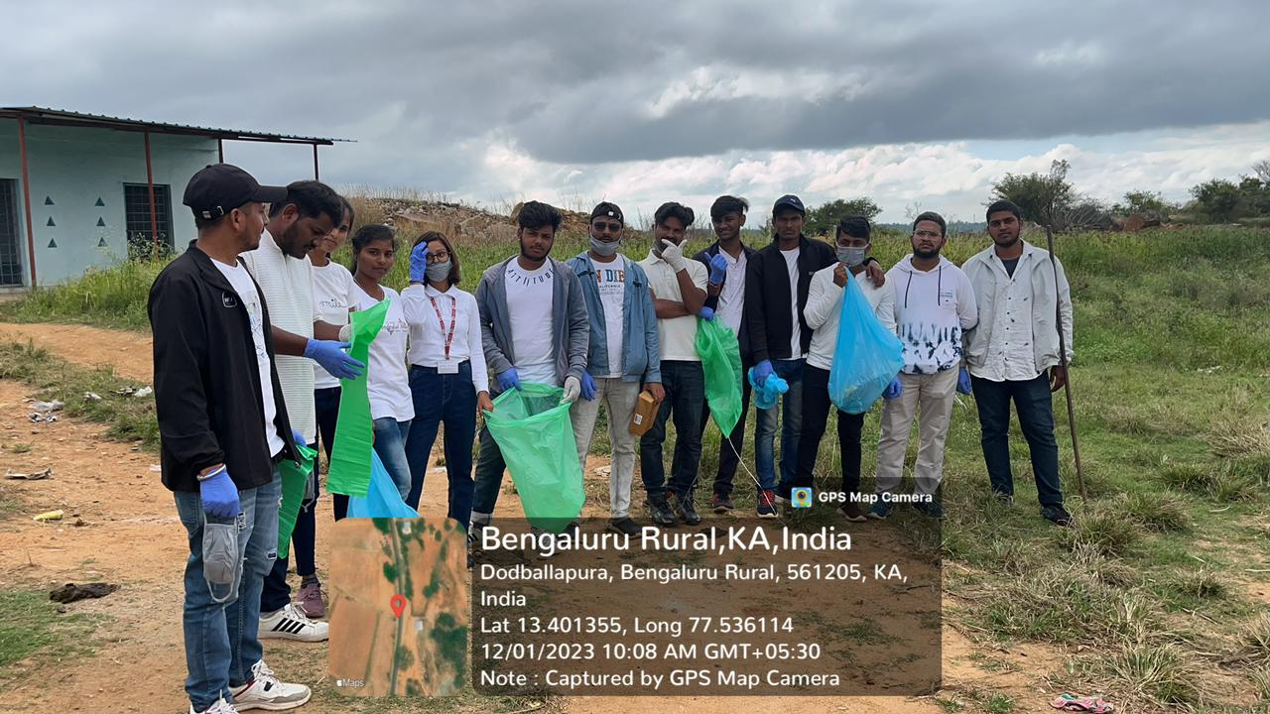

#### Conclusion:

The Swachh Bharat Abhiyan, launched in 2014, has made significant strides in improving cleanliness and sanitation across India. As it concludes, it's evident that the campaign has brought about positive changes, including increased awareness, construction of toilets, and better waste management practices. However, challenges remain, such as sustaining behavioural changes and ensuring universal access to sanitation facilities. Moving forward, continued efforts in maintaining cleanliness, fostering community involvement, and addressing systemic issues will be crucial for the long-term success of Swachh Bharat Abhiyan and for achieving the goal of a cleaner and healthier India.

# DR. AMBEDKAR INSTITUTE OF TECHNOLOGY

(An Autonomous Institution, Affiliated to Visvesvaraya Technological University, Belagavi) Near Jnana Bharathi Campus, Mallathahalli, Bengaluru-560056

### DEPARTMENT OF CIVIL ENGINEERING

NSS ACTIVITY REPORT ON

SOCIAL HARMONY EVENT

TOPIC: “**Visit to Old Age Home**” SUBJECT CODE: 21HSN803

SUBMITTED BY: AMIT R E 1DA21CV006

#### 3rd Year, 5th Sem

‘A’ section

DEPT. OF CIVIL ENGINEERING

#### UNDER THE GUIDANCE OF

Ms. SUPRITHA R M

ASSISTANT PROFESSOR DEPT. OF CIVIL ENGINEERING

#### Dr. Ambedkar Institute of Technology



Visvesvaraya Technological University

Jnana Sangama, Belagavi, Karnataka – 590018 2022-2023

# Dr. AMBEDKAR INSTITUTE OF TECHNOLOGY

(An Autonomous Institution, Affiliated to Visvesvaraya Technological University, Belagavi) Near Jnana Bharathi Campus, Mallathahalli, Bengaluru-560056



**CERTIFICATE**

This is to certify that the report on “SOCIAL HARMONY EVENT” is a bonafide work carried out by AMIT R E (1DA21CV006) of

Dr Ambedkar Institute of Technology, Bangalore. It is certified that all activities instructed for NSS Activity have been incorporated in the report. The report has been approved as it satisfies the academic requirements in respect to the work prescribed for the Bachelor of Engineering degree

|  |  |
| --- | --- |
| **Ms. SUPRITHA R M** | **Dr. S Vijaya** |
| Assistant professor | HOD |
| Dept. of Civil Engg | Dept. of Civil Engg |

**ACKNOWLEDGEMENT**

I take this opportunity to express my sincere gratitude and respect to

**Dr. Ambedkar Institute of Technology,** Bengaluru.

I would like to express my special thanks of gratitude to **Dr. S Vijaya,** Professor, Head of the Department, for creating highly disciplined and professional environment in the department and for his untiring guidance & support for our professional grooming and successful completion of NSS Activity.

I extend my sincere gratitude to our Mentor **Prof. Ms. SUPRITHA R M**, who gave us the golden opportunity to do this activity which also helped us in learning lot of things and we came to know about so many new things. I really thankful to him.

We sincerely thank you for giving us this opportunity to work with such a progressive and forward-thinking organization.

I would also like to thank Renuka Old Age home trust for allowing us to spend some quality times with elderly people and for making this activity a great success.

**Regards** AMIT R E 1DA21CV006

5th sem ‘A’ sec

Dept. of Civil Engineering

Page | 18

## CHAPTER-1

### SOCIAL HARMONY EVENT

#### Visit to Old Age Home:

Place: Renuka Old Age Home Location: Papareddy Palya Date: 13-02-2024

No. of people at old age home: 14

#### Objectives:

* To provide grocery kits and other required essential kits.
* To speak with them and listen to their experience in the old age home.
* To interact with them and make them feel happy.
* To serve food available and spend some quality time.

#### Old Age Home:

“Old age home is a multi-residence housing facility intended for senior citizen.”

We reached their along with all the team members on 12th February 2024. Firstly, we gathered in the meeting hall where the Manager of the organization gave introduction about the organization and facilities rendered by them. Later on, she gave us the orientation of institution and introduced us to their members. There were 14 elderly citizens in old age home. The students of the college interacted with the elderly followed by distributing the essential grocery kits. The inmates were very happy and blessed everyone. It was a joyous occasion with full of satisfaction that the team could bring some rays of happiness among the elderly. It was a pleasure witnessing of such wonderful work i.e. unconditional services.

Objectives of Old Age Home:

* + To help needy aged (above 60 year) irrespective of cast or creed. To provide food shelter and clothing.
  + To provide medical care to improve the health
  + To provide companionship, emotional support, therapeutic occupation, and recreational facilities, and activities to overcome social isolation.
  + To promote self-confidence.

#### 

#### Facilities

* + Proper lighting and drinking water supply.
  + It has also T.V for the entertainment of the old aged.
  + Provide food and cloth to the aged people.
  + It provide bed for the elders.
  + It provide all the basic need of the life.
  + Every month routine health check-up is provided.

**Conclusion**- By visiting old age home we gained knowledge about the feelings of the oldest services and facilities provided to them & how the old age home is maintained.

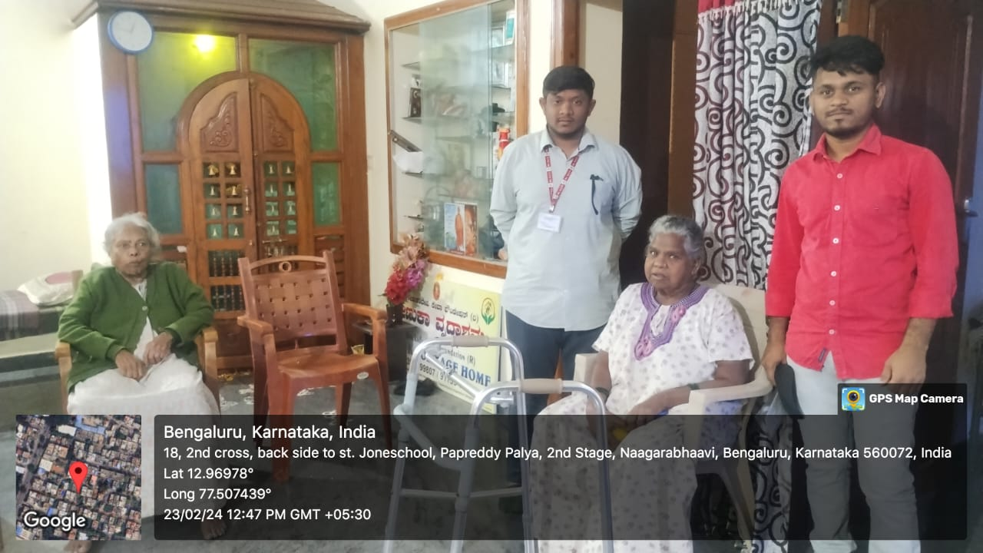

# DR. AMBEDKAR INSTITUTE OF TECHNOLOGY

(An Autonomous Institution, Affiliated to Visvesvaraya Technological University, Belagavi) Near Jnana Bharathi Campus, Mallathahalli, Bengaluru-560056

### DEPARTMENT OF CIVIL ENGINEERING

NSS ACTIVITY REPORT ON

WATER CONSERVATION PROGRAM

TOPIC: “**WATER CONSERVATION PROGRAM**” SUBJECT CODE: 21HSN803

SUBMITTED BY: AMIT R E 1DA21CV006

#### 3rd Year, 5th Sem

‘A’ section

DEPT. OF CIVIL ENGINEERING

#### UNDER THE GUIDANCE OF

Ms. SUPRITHA R M

ASSISTANT PROFESSOR DEPT. OF CIVIL ENGINEERING

#### Dr. Ambedkar Institute of Technology



Visvesvaraya Technological University

Jnana Sangama, Belagavi, Karnataka – 590018 2022-2023

# Dr. AMBEDKAR INSTITUTE OF TECHNOLOGY

(An Autonomous Institution, Affiliated to Visvesvaraya Technological University, Belagavi) Near Jnana Bharathi Campus, Mallathahalli, Bengaluru-560056



**CERTIFICATE**

This is to certify that the report on “WATER CONSERVATION PROGRAM” is a bonafide work carried out by AMIT R E (1DA21CV006) of

Dr Ambedkar Institute of Technology, Bangalore. It is certified that all activities instructed for NSS Activity have been incorporated in the report. The report has been approved as it satisfies the academic requirements in respect to the work prescribed for the Bachelor of Engineering degree

|  |  |
| --- | --- |
| **Ms. SUPRITHA R M** | **Dr. S Vijaya** |
| Assistant professor | HOD |
| Dept. of Civil Engg | Dept. of Civil Engg |

**ACKNOWLEDGEMENT**

I take this opportunity to express my sincere gratitude and respect to

**Dr. Ambedkar Institute of Technology,** Bengaluru.

I would like to express my special thanks of gratitude to **Dr. S Vijaya,** Professor, Head of the Department, for creating highly disciplined and professional environment in the department and for his untiring guidance & support for our professional grooming and successful completion of NSS Activity.

I extend my sincere gratitude to our Mentor **Prof. SUPRITHA R M**, who gave us the golden opportunity to do this activity which also helped us in learning lot of things and we came to know about so many new things. I really thankful to him.

We sincerely thank you for giving us this opportunity to work with such a progressive and forward-thinking organization.

**Regards** AMIT R E 1DA21CV006

5th sem ‘A’ sec

Dept. of Civil Engineering

### WATER CONSERVATION PROGRAM

Place: Vokkaligara Sangha School Location: Papa reddy Palya

## INTRODUCTION:

This report presents an overview of the plantation drive conducted in the Vokkaligara Sangha School. The initiative aimed to promote environmental conservation, increase green cover, and create awareness among the community about the importance of planting trees. The plantation drive was organized with the objective of fostering a greener and more sustainable environment.

**OBJECTIVES:**

The primary objectives of the plantation drive were as follows:

1. Environmental Conservation: The initiative sought to contribute to environmental conservation efforts by planting trees, which play a crucial role in carbon sequestration, biodiversity conservation, and combating climate change.
2. Awareness and Education: The drive aimed to raise awareness among the community, including students and local residents, about the benefits of trees, the importance of afforestation, and the role individuals can play in environmental conservation.
3. Community Engagement: The plantation drive aimed to engage students, school/college authorities, and local community members in a collaborative effort to create a greener and healthier environment.

### ACTIVITIES CONDUCTED:

1. Site Selection and Preparation: Suitable locations for the plantation were identified, considering factors such as soil quality, water availability, and long- term viability. The identified sites were prepared by clearing weeds and debris and ensuring proper soil preparation.
2. Tree Selection: Native tree species suitable for the local climate and ecosystem were chosen for the plantation. The selection process considered factors such as growth rate, adaptability, and ecological benefits.
3. Plantation Process: The participants actively engaged in the plantation process by digging holes, planting saplings, and ensuring proper care and maintenance. They were guided on the correct planting techniques to ensure the healthy growth of the trees.
4. Education and Awareness Sessions: Alongside the plantation activities, educational sessions were conducted to create awareness about the environmental benefits of trees, the role of forests in ecosystem balance, and the importance of individual actions in environmental conservation.

## Impact and Outcomes:

The plantation drive conducted in school yielded several positive outcomes:

1. Increased Green Cover: The initiative led to an increase in the green cover in the targeted area. The planted saplings have the potential to grow into mature trees, contributing to improved air quality, biodiversity conservation, and overall environmental sustainability.
2. Environmental Awareness: The drive successfully raised awareness among the participants and the community about the significance of trees in environmental conservation. The educational sessions helped in disseminating knowledge about the role of forests, climate change mitigation, and the importance of individual actions.
3. Community Participation: The plantation drive fostered community participation and engagement. NSS volunteers, school/college authorities, and local community members collaborated on a common goal, strengthening community bonds and instilling a sense of environmental responsibility.
4. Long-Term Impact**:** The planted trees have the potential to provide long-

term benefits such as shade, soil conservation, and habitat creation for wildlife. As the trees grow, they will continue to contribute to the wellbeing of the environment and the community.

# Conclusion:

The plantation drive organized in school showcased the commitment towards environmental conservation and community engagement. The initiative successfully increased the green cover, raised awareness, and fostered community participation. The efforts of the students, college authorities, and local community members were instrumental in the success of the plantation drive. By nurturing the planted saplings and continuing to promote environmental awareness.

## 

# DR. AMBEDKAR INSTITUTE OF TECHNOLOGY

(An Autonomous Institution, Affiliated to Visvesvaraya Technological University, Belagavi) Near Jnana Bharathi Campus, Mallathahalli, Bengaluru-560056

### DEPARTMENT OF CIVIL ENGINEERING

NSS ACTIVITY REPORT ON

AWARENESS PROGRAM

TOPIC: “**AWARENESS PROGRAM**” SUBJECT CODE: 21HSN803

SUBMITTED BY: AMIT R E 1DA21CV006

#### 3rd Year, 5th Sem

‘A’ section

DEPT. OF CIVIL ENGINEERING

#### UNDER THE GUIDANCE OF

Ms. SUPRITHA R M

ASSISTANT PROFESSOR DEPT. OF CIVIL ENGINEERING

#### Dr. Ambedkar Institute of Technology

Visvesvaraya Technological University

Jnana Sangama, Belagavi, Karnataka – 590018 2022-2023

# Dr. AMBEDKAR INSTITUTE OF TECHNOLOGY

(An Autonomous Institution, Affiliated to Visvesvaraya Technological University, Belagavi) Near Jnana Bharathi Campus, Mallathahalli, Bengaluru-560056



**CERTIFICATE**

This is to certify that the report on “AWARENESS PROGRAM” Is a bonafide work carried out by AMIT R E (1DA21CV006) of

Dr Ambedkar Institute of Technology, Bangalore. It is certified that all activities instructed for NSS Activity have been incorporated in the report. The report has been approved as it satisfies the academic requirements in respect to the work prescribed for the Bachelor of Engineering degree

|  |  |
| --- | --- |
| **Ms. Supritha r m** | **Dr. S Vijaya** |
| Assistant professor | HOD |
| Dept. of Civil Engg | Dept. of Civil Engg |

**ACKNOWLEDGEMENT**

I take this opportunity to express my sincere gratitude and respect to

**Dr. Ambedkar Institute of Technology,** Bengaluru.

I would like to express my special thanks of gratitude to **Dr. S Vijaya,** Professor, Head of the Department, for creating highly disciplined and professional environment in the department and for his untiring guidance & support for our professional grooming and successful completion of NSS Activity.

I extend my sincere gratitude to our Mentor **Prof. Ms, SUPRITHA R M** who gave us the golden opportunity to do this activity which also helped us in learning lot of things and we came to know about so many new things. I really thankful to him.

We sincerely thank you for giving us this opportunity to work with such a progressive and forward-thinking organization.

**Regards** AMIT R E 1DA21CV006

5th sem ‘A’ sec

Dept. of Civil Engineering

# AWARENESS PROGRAM

Place: Vokkaligara Sangha School Location: Papa reddy Palya

## Introduction:

The following report provides an overview of the awareness programme conducted in Vokkaligara Sangha School. The programme aimed to promote awareness among students on various social, environmental, and health-related issues. It was organized with the objective of fostering community engagement, instilling a sense of social responsibility, and encouraging active participation in community service.

## Objective:

The primary objective of the awareness programme was to educate and sensitize students about important social issues and encourage them to take proactive steps towards addressing them. The programme covered various thematic areas such as:

1. Environmental Conservation: we highlighted the significance of environmental preservation, including topics such as waste management, water conservation, and afforestation. They emphasized the importance of individual actions in mitigating environmental challenges.
2. Health and Hygiene: The programme focused on creating awareness about personal hygiene, sanitation practices, and preventive measures against diseases. proper Topics such as hand washing proper waste disposal and maintaining a healthy lifestyle we are covered.
3. Social Issues: we conducted sessions on social issues like gender equality, inclusivity, and the importance of empathy and compassion towards marginalized communities. They aimed to promote a more inclusive and harmonious society.

### Impact and Outcomes:

The awareness programme conducted in Vokkaligara Sangha school yielded several positive outcomes:

1. Increased Awareness: The programme succeeded in raising awareness among students about social, environmental, and health-related issues. Students. Gained a better understanding of their roles as responsible citizens.
2. Attitudinal Change: Through interactive sessions and discussions, the programme fostered a positive attitudinal change among students. They developed a sense of empathy, compassion, and responsibility towards society.
3. Community Engagement: The programme encouraged students to actively engage with the local community. They participated in community service activities and initiated small-scale projects to address specific issues.
4. Skill Development: Students acquired practical skills through workshops and hands-on activities. They developed skills such as waste management, leadership, teamwork, and effective communication.

## Conclusion:

The awareness programme successfully achieved its objectives of promoting awareness, fostering community engagement, and instilling a sense of social responsibility among students. It played a vital role in shaping students' perspectives and nurturing them as responsible citizens. The programme's impact will likely extend beyond the school premises, positively influencing the community at large. The school administration deserves appreciation for their efforts in organizing this impactful initiative.

